**COVID-19 ANALYSIS & VISUALIZATION**

**Team Members**: 22691A05D4, 22691A05D5, 22691A05D6  
**Submitted Date**: 28 November 2024

**2. Problem Statement**

This project analyzes global COVID-19 data to explore trends in cases, deaths, and their links to demographics, healthcare resources, and socio-economic factors. It evaluates government responses using the stringency index and visualizes insights for informed decision-making. The goal is to aid future pandemic preparedness.

**3. Objective**

To analyze and visualize global COVID-19 data using Python and data science techniques, identifying trends, correlations, and the impact of socio-economic and healthcare factors. The project leverages data preprocessing, statistical analysis, and visualization tools to evaluate government responses and provide actionable insights for future pandemic preparedness.

**4. Proposed Method**

**4.1. Workflow: Optimizing Air Quality Predictions**

The workflow for **COVID-19 Analysis & Visualization** follows a systematic approach to transform raw data into actionable insights and meaningful visualizations. The step-by-step process is outlined below:

**1.Data Gathering**  
The first step involves acquiring the COVID-19 dataset from reliable sources, such as **Kaggle**, academic repositories, or other open-source platforms. This dataset includes metrics like total cases, deaths, population demographics, and healthcare indicators.

**2.Data Analysis**  
Before preprocessing, it is crucial to comprehend the dataset's structure and content:

* 1. **Data Types**: Analyze columns to identify numeric, categorical values.
  2. **Features**: Highlight key attributes, such as date, location, total_cases, new_cases, total_deaths, stringency_index, etc.
  3. **Missing Values**: Detect and document incomplete data entries.
  4. **Duplicates**: Identify and handle duplicate records to ensure accurate analysis.

**Tools:**

**Python Libraries:** Pandas, NumPy, matplotlib, seaborn

### **3. Feature Engineering**

Feature engineering involves creating, selecting, and transforming data features to improve the accuracy and effectiveness of analysis and visualization. For **COVID-19 Analysis**, this process focuses on deriving meaningful metrics and preparing the dataset for insightful visualizations or predictive modeling.

#### **Goals of Feature Engineering in COVID-19 Analysis**

* **Enhance Interpretability**: Develop features that are intuitive and facilitate clearer visualizations, such as new_cases_per_million or total_deaths_per_million.
* **Improve Predictive Power**: Generate features like moving averages (new_cases_smoothed) or reproduction rates to better capture trends and patterns.
* **Enable Comparisons**: Normalize metrics like cases or deaths per million population to compare regions effectively, regardless of population size.

**4.Data Visualization**

Here are the commonly used visualizations for COVID-19 data:

* + 1. Line plot.
    2. Pair plot.
    3. Histogram plot.
    4. Violin plot
    5. Box plot.
    6. Scatter plot.

### **5. Model Building**

Model building involves developing predictive and descriptive models to analyze trends, forecast outcomes, and derive actionable insights from the COVID-19 data. This process can include:

* **Statistical Models**: Analyze patterns in time-series data (e.g., cases, deaths) to understand historical trends.
* **Machine Learning Models**: Use techniques like regression or clustering to predict future cases or identify regional patterns.
* **Visualization Models**: Employ Python libraries like **Matplotlib** and **Seaborn** for descriptive analysis and trend visualization.

These models aim to leverage the dataset's features, such as stringency_index, population_density, and gdp_per_capita, to provide a deeper understanding of the pandemic's dynamics.

**4.2. Dataset Collection**

Dataset collection is a crucial initial step in the **COVID-19 Analysis & Visualization** process. Ensuring the use of reliable and comprehensive data allows for meaningful analysis, accurate modeling, and insightful visualizations. The dataset used in this project includes key metrics such as total cases, new cases, deaths, population demographics, healthcare resources, socio-economic indicators, and government response measures. These data points are sourced from trusted platforms like **Kaggle** and other open-source repositories, ensuring credibility and relevance for the analysis.

**4.3. Data Preprocessing**

Data preprocessing is an essential step in preparing the raw COVID-19 dataset for effective analysis and visualization. This process involves cleaning, transforming, and organizing the data to ensure accuracy and consistency. Given the dataset's diverse metrics, such as total cases, deaths, demographic details, and healthcare indicators, preprocessing is critical for handling missing values, duplicates, and data inconsistencies. This ensures the data is structured and ready for meaningful analysis and visualizations.

**1.Data Cleaning**

* Handling Missing Data
* Removing Duplicates
* Removing Outliers
* Apply Standardization
* Apply Normalization

#### **1. Handling Missing Values**

**Why It’s Important**: Missing data often arises from delays in reporting or errors during collection. Addressing these gaps is essential to maintain the completeness and accuracy of the analysis.

**Methods to Address Missing Values**:

* **Remove Rows**: Eliminate rows with missing values if the data points are minimal and not critical for the analysis.
* **Impute Values**: Replace missing values in numeric columns using techniques such as mean, median, or forward-fill methods to preserve data integrity.

#### **2. Removing Duplicates**

**Why It’s Important**: Duplicate entries can bias the analysis and lead to misleading insights. Removing such records ensures the dataset remains clean and accurate.

#### **3. Removing Outliers**

**Why It’s Important**: Outliers, such as abnormally high or unrealistic values, can distort results and impact the reliability of insights. Identifying and handling these anomalies is crucial to ensure the analysis reflects actual trends.

**4.Apply Standardization**

Standardization is a process that rescales the data to have a mean of 0 and a standard deviation of 1. This is done to ensure that all features are on the same scale, which can improve the performance of machine learning models**.**

**5.Apply Normalization**

Normalization is a process that rescales the data to a common range, usually between 0 and 1. This is done to ensure that all features are on the same scale, which can improve the performance of machine learning models**.**

**4.4. Data Visualization**

1. Scatter plot

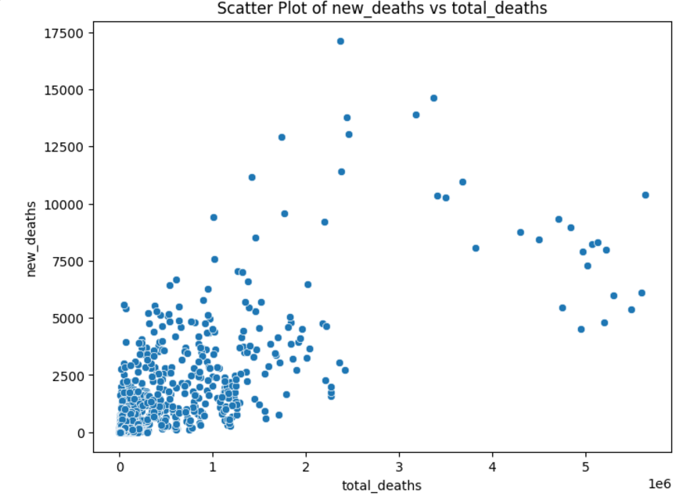

1. Violin plot

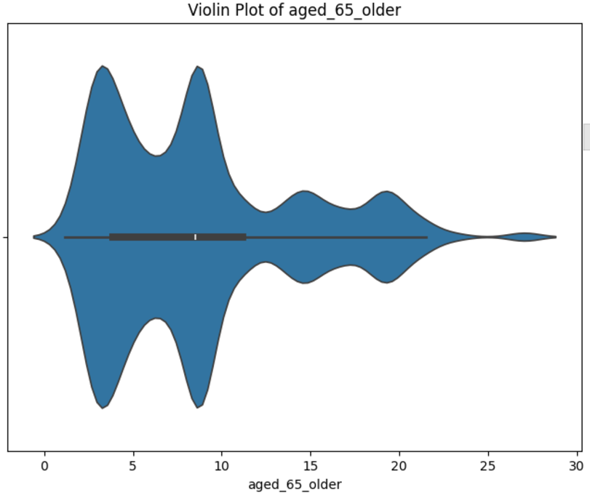

1. Histogram plot

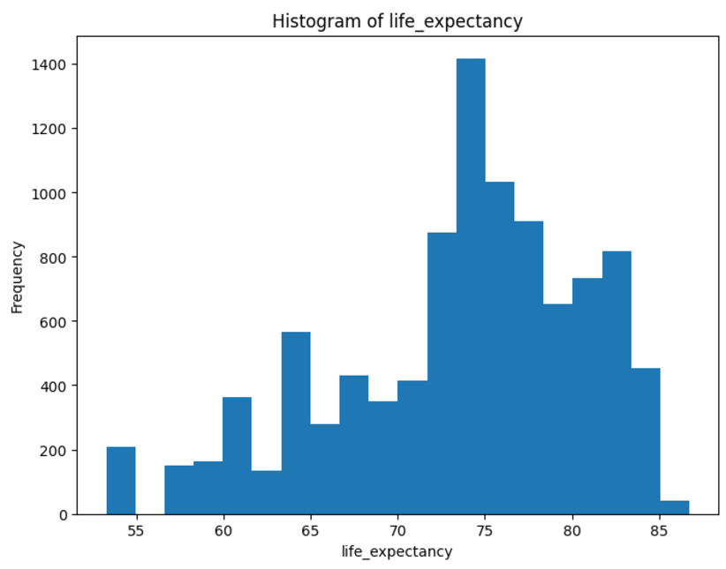

1. Pair plot

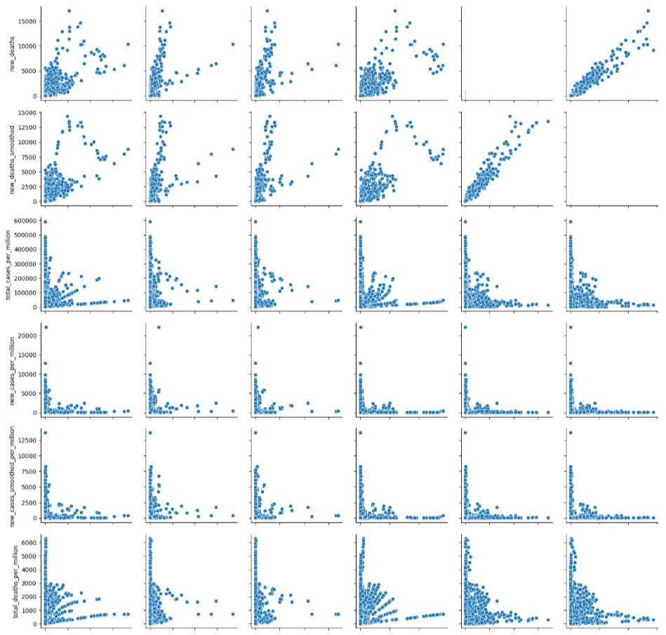

1. Box plot

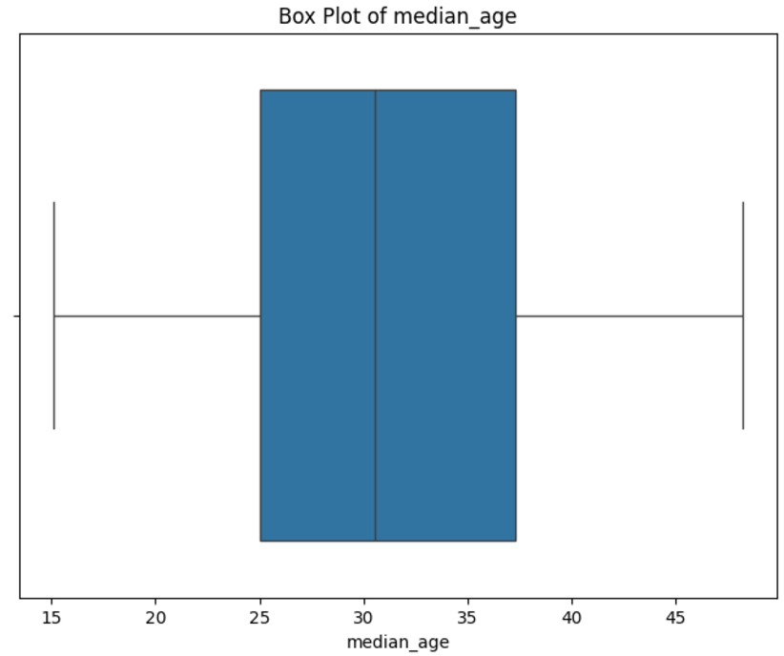

1. Line plot

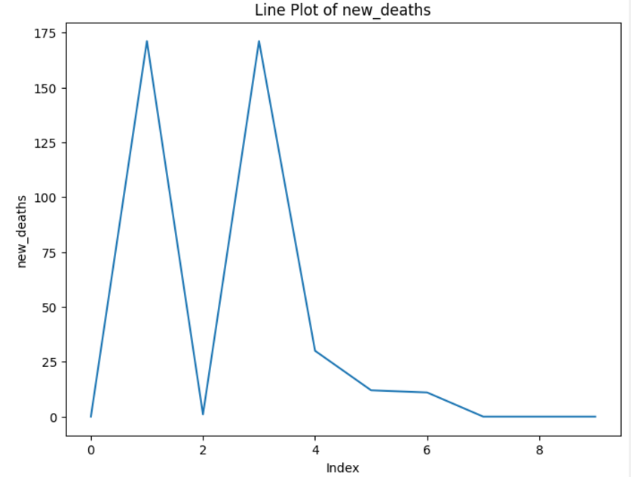

**4.5 Different plots**

**1.Pair Plot**

* **Description**: A pair plot visualizes relationships between multiple numerical variables by creating scatter plots for each pair. The diagonal shows the distribution of individual variables using histograms or KDE plots.
* **Use Case**: Useful for exploring correlations and relationships between variables like total_cases, total_deaths, and stringency_index.

**2.Line Plot**

* **Description**: A line plot connects data points with straight lines, commonly used for time-series data to display trends over time.
* **Use Case**: Ideal for showing trends in daily new_cases or new_deaths over time.

**3.Box Plot**

* **Description**: A box plot visualizes data distribution through quartiles, highlighting the median, interquartile range, and potential outliers.
* **Use Case**: Useful for identifying outliers and comparing the spread of variables like new_cases_per_million across continents.

**4.Histogram Plot**

* **Description**: A histogram shows the frequency distribution of a numerical variable by grouping data into intervals (bins) and plotting their frequencies.
* **Use Case**: Ideal for analyzing the distribution of variables like reproduction_rate or population_density.

**5.Violin Plot**

* **Description**: A violin plot combines box plot and density plot elements to depict data distribution and variability, including probability density.
* **Use Case**: Great for comparing distributions of stringency_index across different continents or regions.

**6.Scatter Plot**

* **Description**: A scatter plot uses X and Y coordinates to visualize individual data points, revealing relationships between two continuous variables.
* **Use Case**: Perfect for analyzing correlations, such as between gdp_per_capita and total_cases_per_million.

**5.Results & Discussion**

### **1. Key Findings from COVID-19 Data Analysis**

#### a. **COVID-19 Cases Over Time**

* **Visualization**: Line plots or bar charts illustrating the trend of COVID-19 cases over time for various countries or regions.
* **Findings**:
  + COVID-19 cases typically exhibit a "wave" pattern, with significant surges during specific periods (e.g., early 2020, late 2020, mid-2021 in many countries).
  + Some countries experience multiple waves, while others show a decline in cases due to stringent public health measures.

#### b. **Impact of Vaccination on Cases**

* **Visualization**: Scatter plots or line plots comparing vaccination rates with COVID-19 cases in different countries.
* **Findings**:
  + Countries with higher vaccination rates tend to show slower increases in cases and lower severity, including fewer hospitalizations.
  + A correlation may exist between higher vaccination rates and a decrease in severe cases or deaths.

#### c. **Recovery and Death Rates**

* **Visualization**: Box plots or violin plots comparing recovery and death rates across countries or regions.
* **Findings**:
  + Recovery rates are generally high across most regions, although death rates vary depending on healthcare infrastructure and the prevalence of underlying health conditions.
  + Countries with better healthcare systems tend to have lower death rates compared to those with limited healthcare access.

#### d. **Demographic Insights**

* **Visualization**: Histograms or pair plots illustrating the age distribution of COVID-19 cases, deaths, and recoveries.
* **Findings**:
  + Older age groups, particularly individuals over 65, exhibit higher death rates and greater vulnerability to severe outcomes.
  + Younger populations, especially those under 30, have lower death rates but still contribute to transmission.

1. **Interpretation of the Visualizations**

### a. **Pair Plot Analysis**

* **Observation**: The pair plot can reveal correlations between variables like "Confirmed Cases" and "Deaths" or "Confirmed Cases" and "Vaccination Rates."
* **Interpretation**: A positive correlation between confirmed cases and deaths may be evident, suggesting that regions with higher case numbers tend to experience more deaths. However, this relationship can be influenced by factors such as healthcare quality and response measures.

### b. **Line Plot Analysis**

* **Observation**: The line plot may depict an exponential rise in COVID-19 cases during the initial stages of the pandemic, followed by a decline or stabilization as vaccination efforts are implemented.
* **Interpretation**: A sharp increase in cases could indicate the start of a new wave, while a decrease following vaccination campaigns or lockdown measures suggests their effectiveness in controlling the spread.

### c. **Box Plot and Violin Plot Analysis**

* **Observation**: These plots display the distribution of COVID-19 cases or deaths across various regions or countries.
* **Interpretation**: Wide interquartile ranges (IQR) in box plots could indicate significant regional variations in case counts or recovery rates, while a tighter distribution might suggest more uniformity in a specific region or country.

### d. **Histogram Analysis**

* **Observation**: The histogram can show the distribution of cases, such as whether most cases are mild or severe.
* **Interpretation**: A right-skewed distribution suggests that most COVID-19 cases are mild, whereas a balanced or left-skewed distribution might indicate a higher proportion of severe cases.

### e. **Scatter Plot Analysis**

* **Observation**: Scatter plots comparing vaccination rates to COVID-19 cases can reveal whether there is a potential negative correlation (higher vaccination rates = fewer cases).
* **Interpretation**: A noticeable trend showing fewer cases in countries with higher vaccination rates may suggest that vaccines play a significant role in reducing the spread and severity of COVID-19.

**6.Conclusion**

The analysis and visualization of COVID-19 data have offered valuable insights into the pandemic's trajectory, the success of different interventions, and the varying outcomes across regions. By employing various data visualizations and statistical techniques, we have identified key trends, including fluctuations in case numbers, the effectiveness of vaccination efforts, and the relationships between public health measures and infection rates.

**7.References**

1.F. Jeanquartier, C. Jean-Quartier and A. Holzinger, "Visualizing uncertainty for comparing genomic pediatric brain cancer data", IV 2019 Part I, pp. 388-391.

2.C.K. Leung, "Uncertain frequent pattern mining", Frequent Pattern Mining, pp. 417-453, 2014.

3.C.K. Leung, M.A.F. Mateo and D.A. Brajczuk, "A tree-based approach for frequent pattern mining from uncertain data", PAKDD, pp. 653-661, 2008.

4.S. Fernando et al., "Compositional microservices for immersive social visual analytics", IV 2019 Part I, pp. 216-223.

**8. Contributors**

| **Name** | **Responsibility** |
| --- | --- |
| M.Monika | Data Collection & Preprocessing |
| T.Monisha | Model Development & Testing |
| J.Mounika | Report Writing & Visualization |

**9. Code Availability**

**GitHub Link**: https://github.com/Mounika1106/Slash-Mark-basic